1000 IU per lb for 7 days
http://homefirst.com/info-1/current-health-news/vitamin-d3.html/?___store=default
Dr. Eisenstein's Daily Vitamin D Recommendations for this season’s Flu starting in October
There is scientific evidence that links low levels of Vitamin D and low levels of Probiotics to an increased risk of many medical conditions. Vitamin D, Probiotics and Chicken soup have been effective in the past in combating viral infections like Flu.
1. Get a Vitamin D blood test 25(OH)D Vitamin D3 Chart
2. Make sure your whole family has adequate blood levels of Vitamin D this flu season (>50-80ng/ml). Most children and adults vitamin D blood level is <30ng/ml. Disease Incidence Prevention by Serum 25(OH)D Level
3. Adult (and children >100 lbs) maintenance ............ 10,000 IU daily.
4. Children's maintenance: <100 lbs........................... 5,000 IU daily.
5. At the first symptoms of a cold or flu 1,000IU/ lb. daily for 7 days.
Examples:
50 lb ................................................................................... 50,000IU daily.
100 lb daily ....................................................................... 100,000IU daily.
150 lb daily........................................................................ 150,000IU daily.
200 lb daily....................................................................... 200,000 IU daily.
6. And of course Chicken Soup
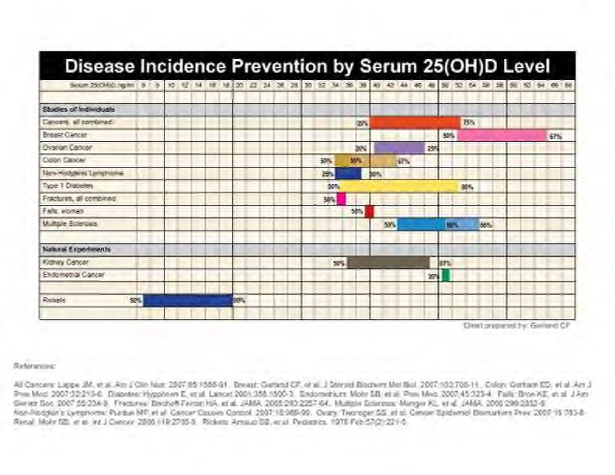

Click on the Graph for a larger image

Vitamin D's Influence on Influenza The reason why public health officials are worried about the current H1N1 flu pandemic , is the fear that there will be a recurrence of the great flu outbreak of 1918 which killed millions of people. It is this fear that has prompted them to come out with a swine flu/H1N1 vaccine. This novel flu vaccine has not been properly tested for safety or efficacy, contains dangerous preservatives such as thimerosal,and may contain dangerous adjuvantssuch as MF59 which contains Squalene.

Athletic Performance and Vitamin D Originally from Med Sci Sports Exerc. 2009 Apr 3.

Avoid Flu Shots, Take Vitamin D Instead Another influenza season is beginning in the northern temperate zone, and our government's Center for Disease Control and Prevention (CDC) will strongly urge Americans to get a flu shot. Health officials will say that every winter 5-20 percent of the population catches the flu, 200,000 people are hospitalized, and 36,000 people will die from it. by Donald W. Miller, Jr., MD

Vitamin D and Breast Cancer Sunlight triggers the formation of vitamin D in the skin, which can be activated in the liver and kidneys into a hormone with great activity. This activated form of vitamin D causes "cellular differentiation" - essentially the opposite of cancer. The following evidence indicates that vitamin D might have a protective role against breast cancer: Synthetic vitamin D-like molecules have prevented the equivalent of breast cancer in animals.

Breast Cancer linked to Low Vitamin D and Omega-3 Levels Three new studies strengthen the associations between suboptimal intake of either nutrient and risk of breast cancer. June 2, 2008
by Craig Weatherby

Dr. Eisenstein's Daily Minimum Recommendation for Vitamin D with Probiotics

H1N1 Vitamin D Vitamin D’s Protective Effects on both Seasonal and H1N1 Influenza

Is Breastmilk Deficient in Vitamin D I am a physician, attorney, father, grandfather and husband of a wife whohas not only been a LaLeche Leader for 17 years, has nursed all six of our children and actively helped our daughters and daughter-in-law nurse our nine grandchildren. I was always bothered by the statement of American Academy of Pediatrics that breastmilk was lacking in Vitamin D. However, when you measure the Vitamin D content in most women’s breastmilk it was truly lacking in Vitamin D.

Kids need 10 times as much Vitamin D Children and teens need 10 times more than the recommended dose of vitamin D, a clinical trial suggests. "Our research reveals that vitamin D, at doses equivalent to 2,000 IU a day, is not only safe for adolescents, but it is actually necessary for achieving desirable vitamin D levels," study leader Ghada El-Hajj Fuleihan, MD, of the American University of Beirut Medical Center in Lebanon, says in a news release. May 28,2009

Lack of Vitamin D may worsen Chronic Pain Researchers from Mayo Comprehensive Pain Rehabilitation Center in Rochester, Minn. report about one in four patients who have chronic pain also have inadequate blood levels of vitamin D, which might contribute to their pain. Patients who did not have enough vitamin D also needed higher doses of morphine for a longer period of time.

Low Vitamin D, it is a root cause of chronic illness and cancer? Seventy seven percent (77%) of U.S. teens and adults are deficient in vitamin D (less than 30ng/mL), ten years earlier, fifty-five percent (55%) were deficient, in the so-called "sunshine vitamin" whose deficits are increasingly blamed for everything from cancer and heart disease to diabetes. By Mayer Eisenstein MD, JD, MPH

More Info Vitamin D, Omega and Cholestral Health According to a recent study in the Archives of Internal Medicine, 75 percent of Americans do not get enough Vitamin D. Researchers have found that the deficiency may negatively impact immune function and cardiovascular health and increase cancer risk. Now, a University of Missouri nutritional sciences researcher has found that vitamin D deficiency is associated with inflammation, a negative response of the immune system, in healthy women.

Take Vitamin D, Live Longer? People Who Take Vitamin D Supplements May Be More Likely to Outlive Others, Experts Say. Taking vitamin D supplements may help people live longer, according to a new research review. But it's not yet clear exactly how vitamin D does that.

Vitamin D Consensus Letter Scientists' Letter on Vitamin D for Cancer and other Disease Prevention. We are aware of substantial scientific evidence supporting the role of vitamin D in prevention of cancer. It has been reasonably established that adequate serum vitamin D metabolite levels are associated with substantially lower incidence rates of several types of cancer, including those of the breast, colon, and ovary, and other sites.

Vitamin D Could Correct Men's Damaged Fertility Sydney, October 21: For decades lower levels of Vitamin D have been associated with unhealthy outcomes in women and children, but now a new Australian research suggests that men too are affected equally.

